supported by:
pRIMARY cARE GP
SUPPORT PACK
Enabling safe certification of deaths in the COMMUNITY

In collaboration with:
INTRODUCTION
The following provides guidance and information to support general practice in the verification and certification of deaths in the community.

WHAT IS REQUIRED OF GENERAL PRACTICE?
- If a practice is notified of an expected or reasonably foreseeable natural death, the information should be shared with a clinician within practice.
- A risk assessment should be completed to ensure it is safe to verify the death.
- The clinician will attend the scene to verify the death and complete the necessary paperwork while at the scene.
- The clinician will scan the relevant information and update the clinical system.
- If the clinician is unable to certify the death (for example due to accident, suicide, violence or neglect) this will trigger a standard police response or if no statement of intent, Clinician is still expected to verify death and immediately report to Coroner. During the ‘out of hours’ period, it will be police.

CHANGE IN LEGISLATION
The Coronavirus Act 2020 received Royal Assent on Thursday 27th March 2020. This now means that:
- Statements of Intent on records are no longer required every 14 days but now every 28 days and can be obtained by remote visual consultation e.g. video skype etc. This is essential to help with expected deaths and reduce referrals to the coroner and can now be updated remotely with no reason to visit or see face to face.

- A medical certificate can be accepted from any medical practitioner, as long as they are able to state to the best of their knowledge the cause of death which can be accessed via records and special notes.

- Practices may wish to consider how they expedite the issuing of death certificates for some faith groups based on urgent needs.

- Registrars can accept medical certificates of cause of death (MCCDs) without referral to the coroner, provided it contains an acceptable cause of death, and indicates that a medical practitioner has consulted with the deceased either within 28 days prior to death or has seen the body after death. When completing the MCCD please note that probable or possible COVID-19 is not acceptable. With agreement of registrars in GM please write COVID-19 in 1a on MCCD whether they are confirmed cases or not if you believe that the COVID type symptoms escalated and caused death.

- After verification of death any medical practitioner can do the MCCD, considering there is a valid statement of intent in place. If there is no valid Statement of intent in place, the verifying GP can issue the MCCD if happy to give cause of death.

- Permission is granted for MCCD to be emailed to registrar and as it is NO LONGER ACCEPTED TO GIVE THE MCCD TO DECEASED FAMILY AS FACE TO FACE APPOINTMENTS THE WITH REGISTRAR NO LONGER TAKE PLACE.

- Please inform deceased family of the content of the MCCD , scan both side of the MCCD and email to the local registrar.

- PLEASE ADVISE FAMILY THAT THE ABOVE WILL HAPPEN AND THEY DO NOT NEED TO ATTEND THE REGISTRAR IN PERSON. The body can be moved after verification.

- The list of qualified informants has been temporarily extended to include a funeral director (where they are acting on behalf of the family)

- Cremation no longer requires the confirmatory medical certificate (cremation form 5), but still requires the completion of the medical certificate (cremation form 4) which can be filled by anyone even if not seeing the deceased after death.

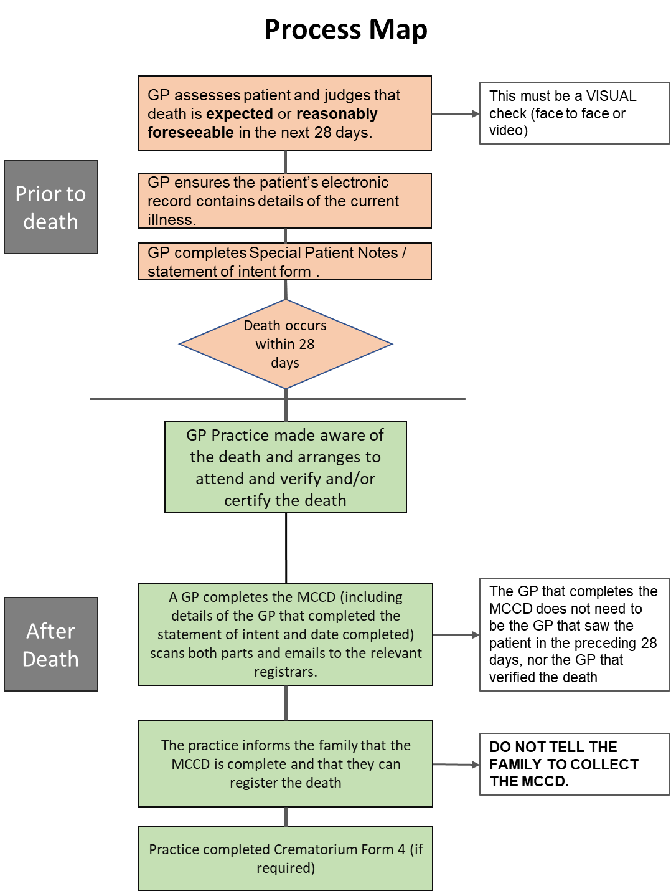

Unexpected deaths: such as road traffic collisions, suicides and accidents. This will be managed via the standard emergency service response.
You will need to still verify a death where special notes are not available. You will still VERIFY deaths but report it to coroner.
Please consider if family /Home has additional information such discharge letter from hospital (with in last 28 days) giving diagnosis and name of Dr Seen patient. This information will make the death an ‘expected death’ considering no other reasons to report it to coroner.

Expected death / reasonably foreseeable natural deaths
When referring to ‘expected deaths’ this could be defined as:
“the result of acute or gradual deterioration in the patient’s health and often due to advanced disease and terminal illness”

When referring to death of ‘reasonably foreseeable natural deaths’ this could be described as:
“To the best of a Doctors knowledge and belief the death was anticipated to occur at any time from natural causes”

useful documents
- VERIFICATION FORM

- CREMATION 4 FORM (replacing Form B)

- EXAMPLE FAMILY LETTER (AS USED BY ESCDC)

- Coronavirus Act – excess death provisions: information and guidance for medical practitioners

TEAM SAFETY

Your safety is paramount so please ensure you risk assess the situation and access Personal Protective Equipment (PPE) – see below.

TRAINING FOR CLINICIANS
We are keen to ensure that you feel fully prepared ahead of certifying deaths in your community. Below you will find details of the training and guidance which may be of use to you.
PERSONAL PROTECTIVE EQUIPMENT (PPE)

ONLINE TRAINING (FREE)
Health Education England e-Learning for Healthcare (HEE e-LfH) has created an e-learning programme in response to COVID-19. The programmes are free to access for the entire UK health and care workforce. As per the screenshot below, this includes PPE. Access the training at:
https://www.e-lfh.org.uk/programmes/coronavirus/

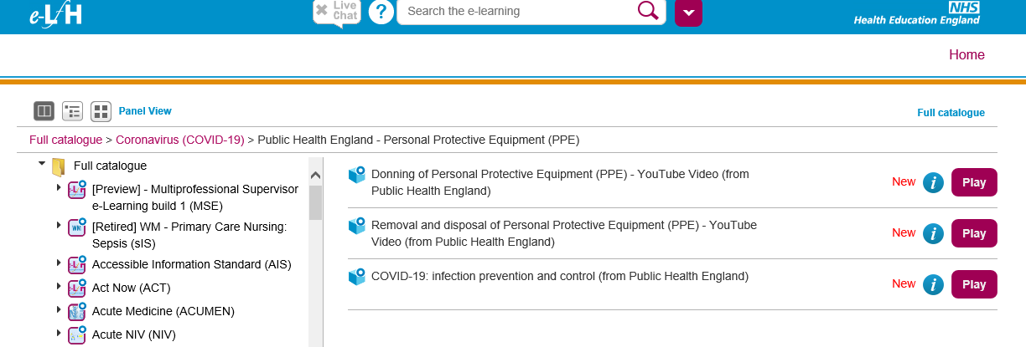

COMPLETION OF RELEVANT DOCUMENTATION
We recognise that GPs are trained in verifying and certifying deaths. However, if you have not done this for some time, or would need a refresher, please see below for further guidance:
- https://www.gov.uk/government/publications/guidance-notes-for-completing-a-medical-certificate-of-cause-of-death
- https://patient.info/doctor/death-recognition-and-certification
- https://www.manchester.gov.uk/downloads/download/7152/guidance_for_completing_mccd
- https://www.themdu.com/guidance-and-advice/guides/signing-death-certificates-and-cremation-forms
- https://www.bma.org.uk/advice/employment/gp-practices/service-provision/confirmation-and-certification-of-death

Please note that as the legislation has only just changed, some guidance has not yet been updated (please see Change in Legislation section on page 2), however the processes of verifying a death and completing the Medical Certificate of Cause of Death (MCCD) have not changed.

INFORMATION GOVERNANCE
ELfH provides free training regarding Information Governance should you require an update:
eLfH - http://www.esrsupport.co.uk/catalogue.php5?m=fullList
MENTAL WELLBEING SUPPORT
We appreciate that this type of work may prove challenging, and that your mental wellbeing could be affected. Please see below a range of options you may wish to consider should you require additional support.
NHS PRACTITIONER HEALTH SERVICE
https://www.practitionerhealth.nhs.uk/
Service is confidential and can be accessed between 8am-8pm weekdays and 8am-2pm weekends by emailing gp.health@nhs.net or calling 0300 0303 300
Practitioner Health have teamed up with SHOUT to create a confidential 24/7 text service for PH patients. Shout is the UK’s first 24/7 text service, free on all major mobile networks, for anyone in crisis anytime, anywhere. Text NHSPH to 85258.

BMA WELLBEING SUPPORT SERVICE
(Open to all doctors, not just BMA Members)
www.bma.org.uk/advice/work-life-support/your-wellbeing/counselling-and-peersupport
Access counselling 24/7 on 0330 123 1245
The counselling service is staffed by professional telephone counsellors, 24 hours a day, seven days a week. All counsellors are members of the British Association for Counselling and Psychotherapy and are bound by strict codes of confidentiality and ethical practice.

To access the counselling service by live chat or email, visit this online portal and log in with the following details:
Username: BMA
Password: Wellbeing
Go to the 'Contact us' tab at the top of the page. You can then request support via the contact form or the live chat button, stating 'BMA' as your organisation/company.

DOCTORS SUPPORT NETWORK
www.dsn.org.uk
An independent, confidential and friendly self-help group for doctors who have experienced mental distress or mental health problems. The service is for doctors and run by doctors. The purpose of the group is to learn to be kinder to ourselves and others and to know we are not alone. The DSN currently has regular meetings throughout the country. The organisation is growing and has plans for meetings in other areas in the future.
Tel: 0870 321 0642

DOCHEALTH
www.dochealth.org.uk
DocHealth is a confidential, not for profit service giving doctors an opportunity to explore difficulties, both professional and personal, with senior clinicians. This service is delivered by Consultant Medical Psychotherapists based at BMA House in London.
Tel: 020 7383 6533
Email: enquiries@dochealth.org.uk

SAMARITANS
Whatever you're going through, a Samaritan will face it with you. Available 24/7, 365 days a year.
Call free on 116 123

MEDICAL PROTECTION SOCIETY
MPS provide counselling support via ICAS, with immediate access to support 24/7. Call ICAS on 0808 189 4385 and quote your MPS membership number to book a free session

GREATER MANCHESTER MENTAL HEALTH (GMMH)
24/7 helpline available - 01204 483071

UNMIND
The workplace mental health platform Unmind has also given all NHS staff free access when they log in with an NHS email account. The site is designed to enable you to assess, track, and understand your mental wellbeing over time. Visit: https://nhs.unmind.com/signup.

SILVER CLOUD
Free online support for mental health and wellbeing – available for all Greater Manchester residents.
Silver Cloud offers a number of online programmes to help ease stress levels, improve sleep or build resilience. Each programme uses proven methods, including cognitive behavioural therapy, and all information entered is anonymous, confidential and secure. Visit: https://gm.silvercloudhealth.com/signup/
GM RESILINECE HUB
Greater Manchester Resilience Hub is also providing emotional support to all health and care workers, and their families, living or working in Greater Manchester. Covid has created challenging and uncertain times, as we’ve been asked to change our routines and how we take care of ourselves and our families.
For many of you, these challenges are even greater, working in unfamiliar environments, with reduced staffing levels, and learning new skills. This is on top of the worry about your own and your family’s health and wellbeing.
https://www.penninecare.nhs.uk/mcrhub-covid19

frequently asked questions
What do I include in the MCCD?

‘Probable or possible COVID-19’ is not acceptable. With agreement of registrars in GM please write COVID-19 in 1a on the MCCD whether they are confirmed cases or not if you believe that the COVID type symptoms escalated and caused death.

Upon certification of death, it is mandatory to have the name and GMC number of the doctor that last reviewed the patient whilst alive. The date of this review is needed also. This is needed on the MCCD in the section 'Last seen alive by me.' Put a line through 'me' and then add the name of the doctor.

When signing the MCCD, you must amend the declaration where it says 'in medical attendance' to say 'NOT in medical attendance.' 'NOT' can be written just above the declaration. Again, this is only if you have not been one of the patient's treating clinicians.

What do I include in the Cremation Form?
When completing the cremation form, you must include who the saw the patient upon verification of death. This can be on page 2 in the box that requires notes on the examination of the body made at death. Include the title, name and GMC/NMC number of the verifying clinician.

Once the MCCD has been completed, it can be emailed to the appropriate registrar's office. The family should then be informed that they need to make a telephone appointment with the registrar to register the death. This allows for face to face contact to be minimised where possible.

What happens with cremation forms?
Cremation no longer requires the confirmatory medical certificate (cremation form 5), but still requires the completion of the medical certificate (cremation form 4) which can be completed by anyone even if they are not seeing the patient after death.

Who liaises with the Funeral Directors?
The family of the deceased/practice would liaise with the funeral director.
Following the registration of the death, the registrar will issue the ‘green form’ (release form) to the funeral director. The document authorises the release of the deceased to the funeral director and authorises the funeral to go ahead.
The crematorium form should be sent electronically to the nominated funeral director.

Is it safe to send information electronically to Funeral Directors?
Information should be sent to the secure email address provided by the funeral director. If completing the Crematorium form 4, this should be completed, signed, (scanned if applicable) and sent to the secure email address.

When should a death be referred to the coroner?
There are a number of circumstances where you will need to refer a death to the coroner. These include (but are not limited to):
If there is no doctor at all who can sign the MCCD - for example, because a patient who was previously well dies suddenly and unexpectedly at home - the coroner must be informed of the death.
If a patient dies with no statement of intent in place, and they have not been seen (including virtually) by a doctor in the previous 28 days and verifying GP can not issue MCCD.
Death due to: Poisoning, exposure to, or contact with a toxic substance, the use of a medicinal product, the use of a controlled drug or psychoactive substance, violence, trauma or injury, self-harm, neglect, including self-neglect, a person undergoing any treatment or procedure of a medical or similar nature, an injury or disease attributable to any employment held by the person during the person’s lifetime, the persons death was unnatural but does not fall within any of the above circumstances, the cause of death is unknown
Further guidance can be found:
Guidance for registered medical practitioners on the Notification of Deaths Regulations’ https://assets.publishing.service.gov.uk/government/uploads/system/uploads/attachment_data/file/851972/registered-medical-practitioners-notification-deaths-regulations-guidance.pdf

How do I contact my local registrar?
Register offices are now closed to the public. Families should contact their local register office by calling one of the numbers below
Bolton | 01204 331185
Bury | 0161 253 6026
Rochdale | 01706 924784
Manchester | 0161 234 5005
Salford | 0161 793 2500
Tameside | 0161 342 5032
Trafford | 0161 912 3026
Wigan | 01942 489003
Stockport | 0161 217 6007
Oldham | 0161 770 8960
Glossop | 01629 531503

Do I need to report COVID-19 death to Coroner?
COVID-19 is an acceptable, direct or underlying cause of death for the purposes of completing the Medical Certificate of Cause of Death (MCCD)

COVID-19 is not a reason on its own to refer a death to a coroner under the Coroners and Justice Act 2009, nor should it be referred under the Registration of Births and Deaths Regulations 1987 (unless there is some other reason for the referral).

Please note that ‘probable’ or ‘possible’ COVID-19 is not an acceptable cause of death. With agreement of registrars in GM please write COVID-19 in section 1a on MCCD certificate whether they are confirmed cases or not if you believe that the COVID type symptoms escalated and caused death.
If the doctor has used such a term, without the support of another acceptable cause of death then, during the emergency period, rather than immediately reporting to the coroner registrars should firstly try to seek a fresh MCCD from the doctor. Further advice should be sought from GRO in respect of any issues or difficulties relating to this issue

Is COVID-19 is a notifiable disease?
COVID-19 is a notifiable disease under the Health Protection (Notification) Regulations 2010. This does not mean referral to a coroner is required by virtue of its notifiable status (this requires that the medical practitioner separately notifies Public Health England).

Does a GP from a practice still need to visit the crematorium?
No

Who liaises with the family?
The GP that verifies and certifies the death will inform the family of cause of death.
The verifying GP should provide the family with details of the next steps.
Please ensure the completed MCCD mirrors the information given to families regarding cause of death

What happens once the MCCD is completed?
Registrars can now accept MCCD forms without referral from the coroner, provided it contains an acceptable cause of death and indicates that a medical practitioner has seen the deceased either within 28 days prior to death or has seen the body after death. The MCCD form should no longer be given to the family as there will be no face to face appointments with the registrar. The family, however, must be informed of the content of the MCCD.
Once completed, both sides of the form should be scanned by the certifying clinician and emailed to the appropriate local registrar. The family should be notified that they can contact registrar to register the death.

Can the family book the funeral?
The registered GP is asked to act as a liaison point for the deceased family.

FURTHER INFORMATION:
If you have any questions regarding the service, please contact:
GM Primary Care Team:
england.primarycarecomms@nhs.net
https://gmprimarycare.org.uk/coronavirus/#certification-of-deaths
https://www.gmhsc.org.uk/

