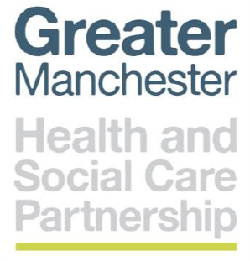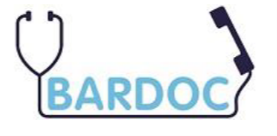

Dear Family member
Re: Enabling Safe Certification of Deaths Service (ESCDS)

Please accept our sincere condolences on the death of your family member.
The ESCDS clinician attended your family’s premises to verify the death on________2020.
You should now be in possession of:
- Verification of death; this document describes the cause of death
- You can inform the Funeral Directors that you are in receipt of the verification of death, which will allow them to remove the body.

It is important you allow the ESDCS to complete the necessary documents (Death Certificate). On completion, a member of the ESCDS team will call you. If we leave a message, there is no need to call us back.
Please allow up to 48hrs for this to be completed.

What do I do next?
Registering the Death: It will be necessary to register the death, however only contact the register officer after the ESCDS service has confirmed all the necessary paperwork is in place.
If Cremation Certificate is required: The GP surgery is best placed to provide the cremation certificate, contact them once the ESCDS has called you.

Support can be obtained from the Greater Manchester Bereavement Service:
Website: https://greater-manchester-bereavement-service.org.uk/
Call 0161 983 0902

